Letter / Email Template

Your Logo Here
This is template was created on the 17th March 2020; With advice changing daily, please ensure the information below is accurate in time of circulation and in line with government recommendations.

Dear Families,
Please be assured that we would never put the health of your child, you, your family or our staff at risk, and as a responsible swim school business we are closely monitoring the COVID-19 outbreak and operating in line with the UK Government’s official advice.
We have also sought advice from our national swimming governing body, the Swimming Teachers’ Association (STA) who are also monitoring the UK Government’s response.
As a swim school business, we will always put the health and safety of our staff and customers first and we are currently doing all we can to ensure the highest standards of hygiene and in line with recommendations, we have ramped up our cleaning and cleansing routines. We also need your help as personal hygiene - as is always the case - when out of the water is of the upmost importance:
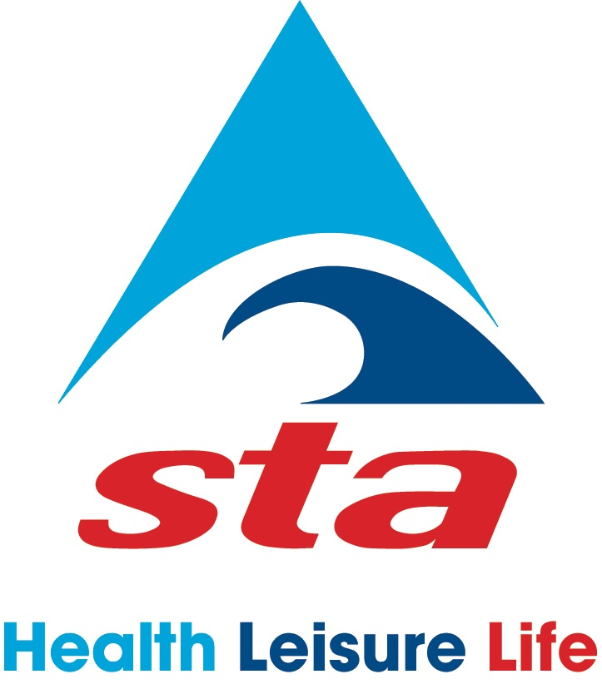

- There is soap and hot water in the changing rooms for handwashing, and as normal practice we highly recommend children shower before and after swimming.
- Disinfect (anti-bac) your hands after you’ve pushed and pulled door handles or touched your locker.
- Experts also advise to wash and maintain clean swimming kit and towels, using a high 60-degree wash to kill any bugs.

We also urge children or parents/carers who may have a slight cold (not coronavirus) to not come to class to minimise the risk of spreading any germs. (This is good practice anyway and may be a very valuable lesson we all learn from this current shared experience.)
In the event the UK Government or local authority advises us to close one or all of our pools we will of course follow the rules and suspend lessons for the required period of time. We will reopen when we are advised to do so and when it is considered safe for staff and clients alike. If we have to close for several weeks then we will stop and start again, and keep you informed.
We are a family business and we call upon our customers at this time to remain calm and continue to support us. If families are not at risk, do not fall into the high-risk category and their children are still attending school, preschool or after-school clubs but choose to stop swimming then our business will be impacted. Sensible, calm and rational, decisions will prevent this from happening.

We urge you to keep up to date with the latest information from Department of Health and Social Care and Public Health England, which provides advice on:

What to do if you have symptoms
Number of cases
Risk level
Recent government action
Diagnosis and analysis
Further information

There is no question these are worrying times, but together with calm and sensible responses and accepting sound advice from official government authorities, we will all get through this. Panic and hysteria are not the way forward.

Thank you in advance for your continued support.

Yours in Swimming
Swim School Contact Information

